Review:
- Convert DC Machine model to LaPlace Domain
- Determine output (speed) perturbations caused by input (voltage, load torque) perturbations

Equation | Time Domain Representation | LaPlace Domain Representation
Armature | v_{a}(t) = R_{a} i_{a}(t) + L_{a} + e_{a}(t) | V V_{a}(p) = R_{a} I_{a}(p) + L_{a} p I_{a}(p) + E_{a}(p)
Field | v_{f}(t) = R_{f} i_{f}(t) + L_{f} | V_{f}(p) = R_{f} I_{f}(p) + L_{f} p I_{f}(p)
Mechanical | J + b ω(t) + T_{L}(t) = T_{em}(t) | J J s ω(p) + b ω(p) + T_{L}(p) = T_{em}(s)

Block Diagram of DC Motor

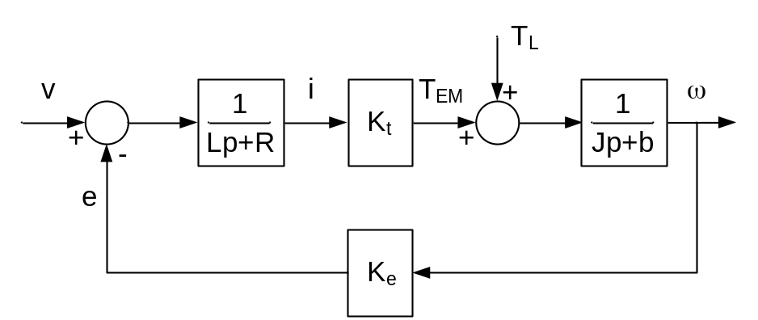
Block Diagram of a DC Machine

ω = ( T_{em} – T_{L}) T_{em} = K_{t} I_{a}

I_{a} = ( V_{a} – E_{a}) E_{a} = K_{e} ω

ω = V – T_{L}

By superposition, we can look at response of output (speed) due to each input (voltage or load torque) independently.

= speed/voltage TF

= speed/load (disturbance) torque TF

How do small perturbations in voltage effect speed?

=

For sinusoidal inputs, set p → j ω

=

It’s important to remember how to find magnitude and phase of a complex function.

=

=

Note:
- Need to be able to find transfer function from block diagram
- Need to understand TF
  - Need to be able to find magnitude of perturbation
  - Need to be able to find phase angle

Introduction to AC Induction Machines:
Basic Theory of Squirrel Cage Induction Machines:

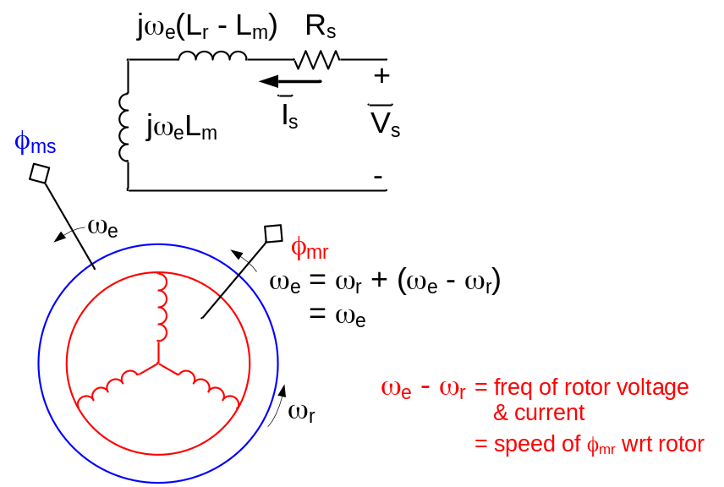 | ω_{e} = excitation frequency  ω_{r} = rotor electrical speed  ω_{em} =  ω_{rm} =

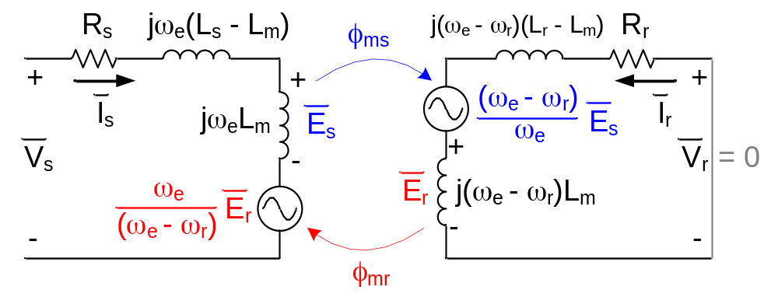
Per Phase Equivalent Schematic of Induction Motor

Circuit Model of Induction Motor

stator: V_{s} = I_{s} + j ω_{e} L_{m}I_{s} + j ω_{e} L_{m}I_{r}

rotor: 0 = j L_{m} I_{s} + j L_{m} I_{r} + I_{r}

multiply rotor equation by = = 0

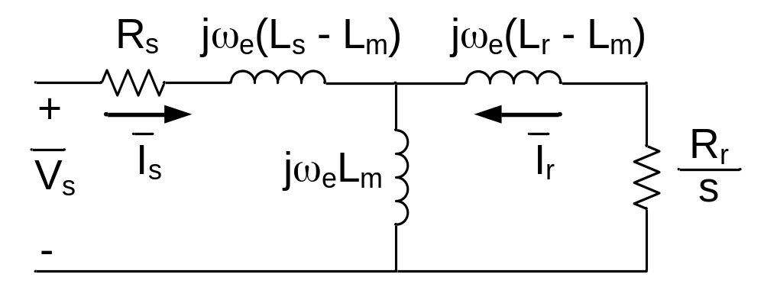
Per Phase Equivalent Schematic of Induction Motor Reflected to Stator

multiply rotor equation by ‘a’ = 0 and introduce a new rotor current =

0 = j ω_{e} a L_{m} I_{s} + j ω_{e} a² L_{m} +

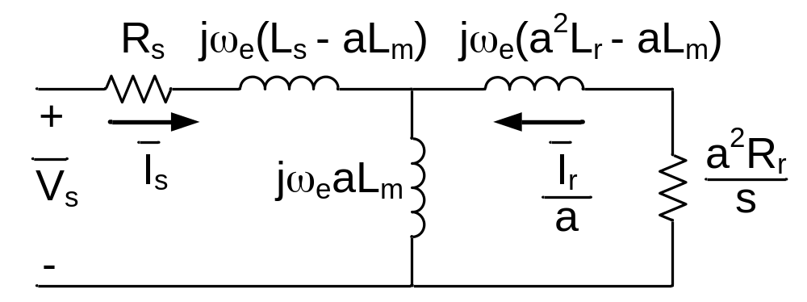
Per Phase Equivalent Schematic of Induction Motor Reflected to Stator

Conventional Per Phase Equivalent Circuit:

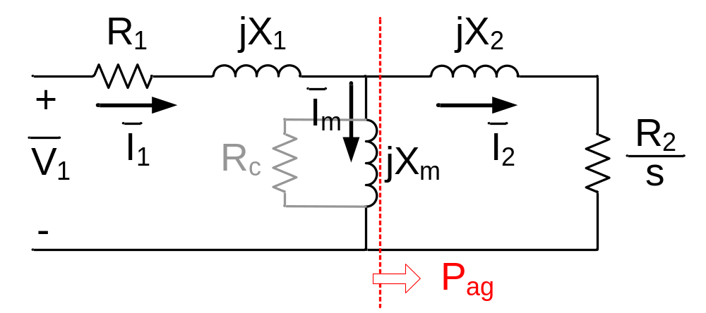
Per Phase Equivalent Schematic of Induction Motor Reflected to Stator

a = R₂ = ²R_{r}
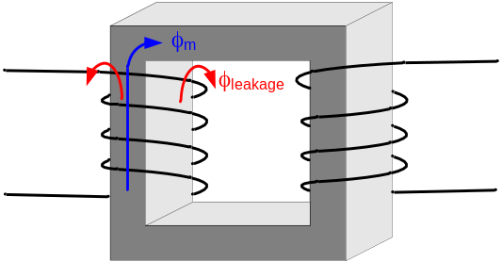

X₁ & X₂ are called “Leakage” Inductances

X₁ = ω_{e}

X_{m} = L_{m} ω_{e}

Airgap Power:

P_{ag} = → 3 I2 R₂ = s P_{ag}

Rotor Loss = s P_{ag}

P_{out} = = P_{ag}

A good (efficient) induction motor must run with low slip.

Electromagnetic Torque:

T_{em} = = = = =

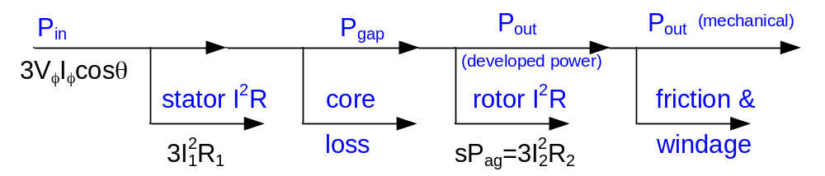
Power Flow in an Induction Motor

What makes a good induction motor?
}
Lots of copper
R₁ → small as economically possible

R₂ → small as economically possible

X_{m} → large as economically possible } Lots of good iron & short air gap

X₁,X₂ → ???

------------------------------------------ ----------------------------------------

Conventional Per Phase Equivalent Circuit:

Per Phase Equivalent Schematic of Induction Motor Reflected to Stator

T_{em} = = P_{ag} = 3 P_{out} = (1 – s) P_{ag}

For a “good” motor

for sure:
R₁ → 0 economics only (amount of wire)
X_{m} → ∞ economics only (small air gap, good magnetic steel)

probably:
Large T_{max} (good)
Large Current at T_{max} (bad)
Large Starting Currents (bad)
R₂ → 0
X₁ , X₂ → 0

Max P_{ag} (assuming small R₁ large X_{m}):

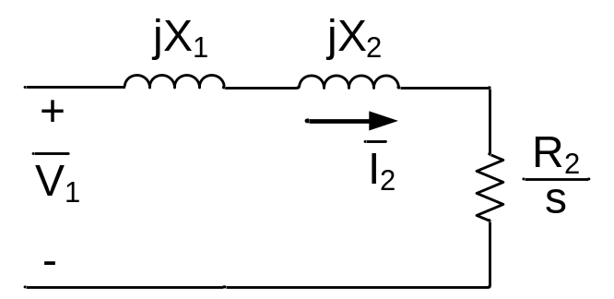
Per Phase Equivalent Schematic of Induction Assuming Small R₁ and Large X_{m}

Max P_{ag} when:

= X₁ + X₂

s_{mt} =

P_{ag_mt} = 3 I2 = = =

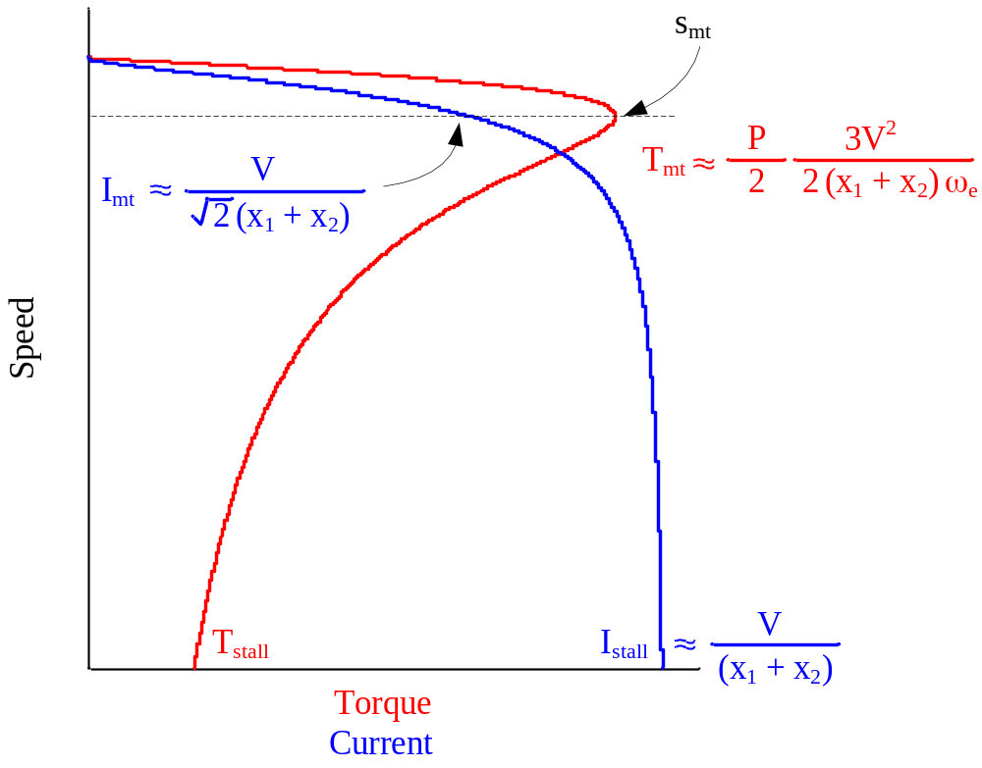
Speed vs. Torque and Current for Three Phase Induction Motor

Wound Rotor Induction Motor:

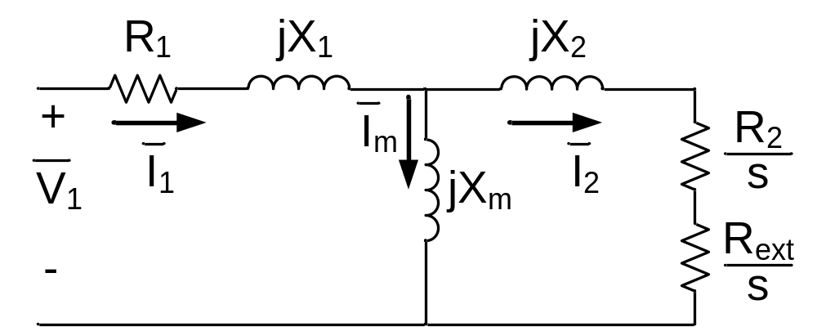
Per Phase Equivalent Schematic of Wound Rotor Induction Motor

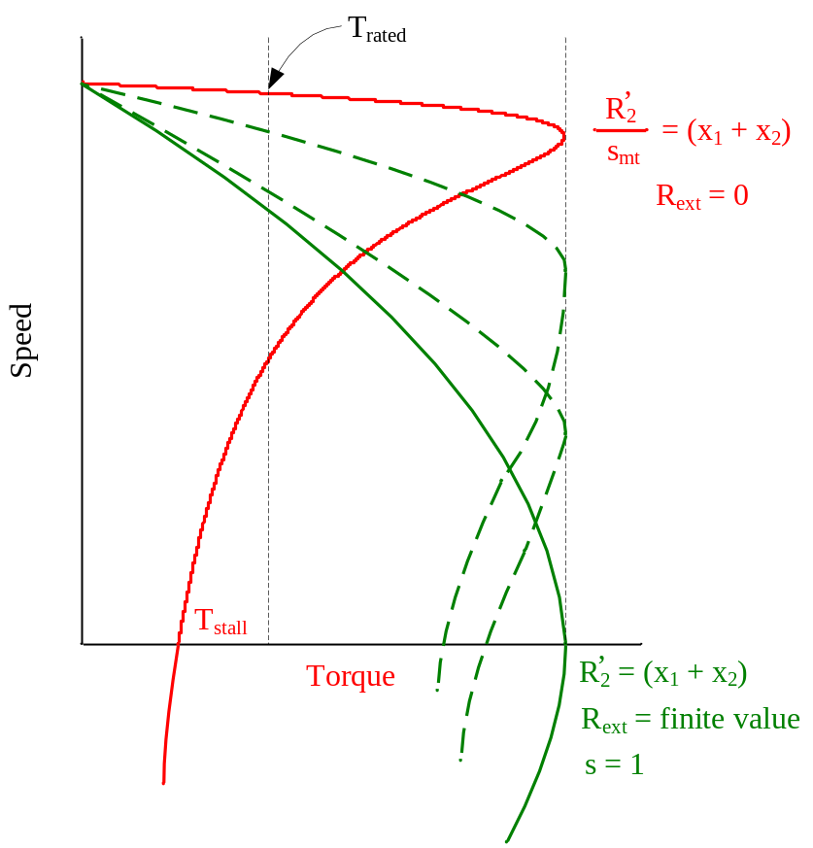
Speed vs. Torque and Current for Wound Rotor Induction Motor

Exact solution for slip for maximum torque:

Find slip for maximum torque analytically

total impedance

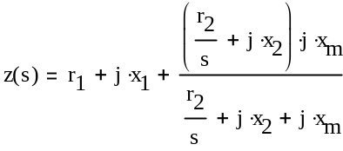

stator current

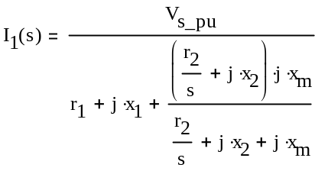

mutual voltage

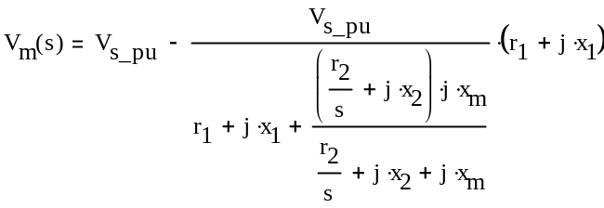

rotor current

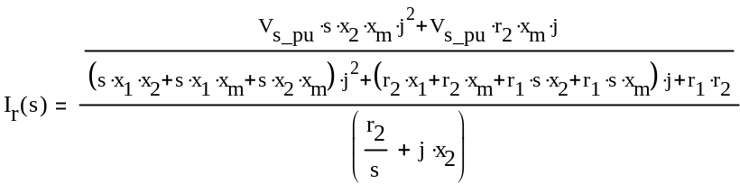
=

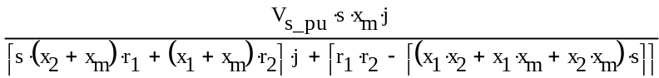

magnitude of rotor current

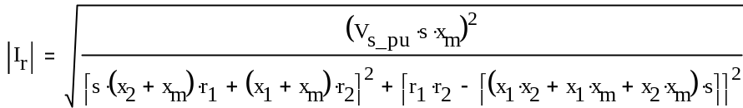

Torque
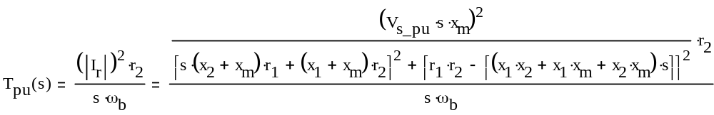

Differentiate torque with respect to slip and set to zero to maximize
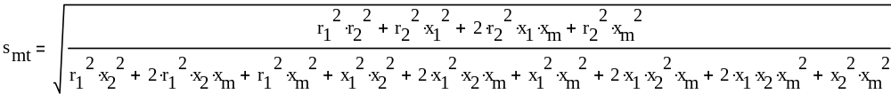

------------------------------------------ ----------------------------------------

Now, the easy way:

Thevenin Equivalent Circuit for a voltage source

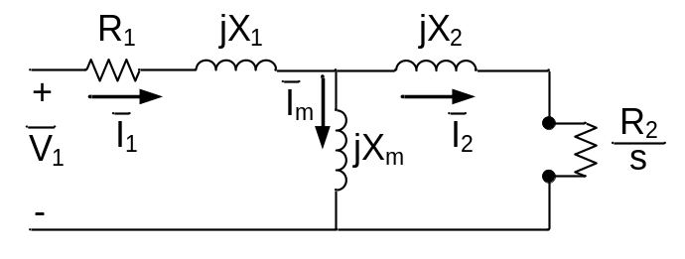 | 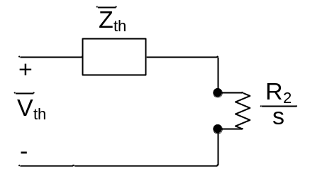
Thevenin Equivalent Circuit

Z_{th} = jX₂ + jX_{m} //

= |Z_{th}| = |jX₂ + jX_{m} // |

T_{mt} = 3 = 3 |Z_{th}| independent of R₂

Per Unit Representation of Machines

P_{b} = P_{r} V_{b} = V_{rφ} ω_{b} = ω_{e_rated}

P_{b} = 3 V_{b} I_{b} → I_{b} = = =

Z_{b} = = = ω_{mb} =

T_{b} = =

I_{r} = = = >> 1.0

T_{r} = = = > 1.0

= =

V_{pu} = I_{pu} Z_{pu} P_{pu} = V_{pu} I_{pu} cosθ

= = =

for a good motor:

 | Large Machines |  | Small Machines
R₁ → 0 | 0.01 | < R₁ < | 0.07 | pu
X_{m} → ∞ | 5.0 | > X_{m} > | 1.0 | pu
R₂ | 0.012 | < R₂ < | 0.084 | pu
X₁ , X₂ | 0.25 | < X₁ + X₂ < | 0.15 | pu

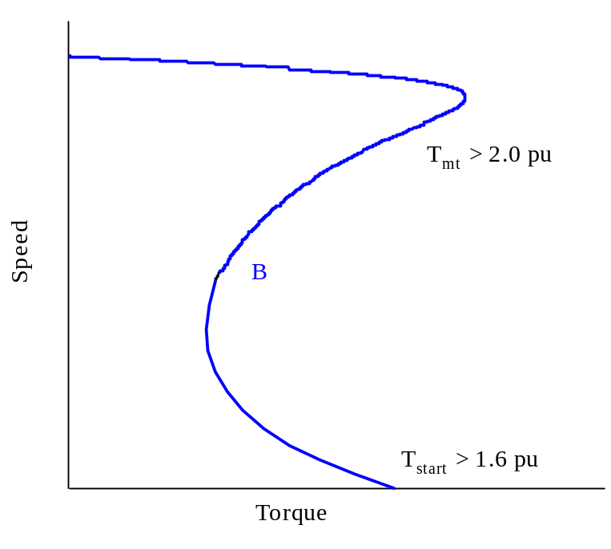
Typical pu Speed Torque Curve for a NEMA Class B Induction Motor

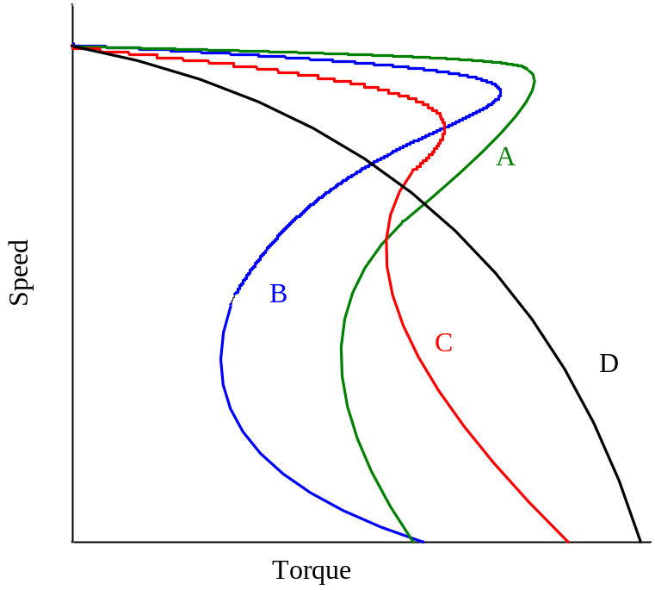 | A – Low Slip (High Efficiency)  B – Standard  C – High Start Torque  D – High Slip
NEMA Standard Class Motors

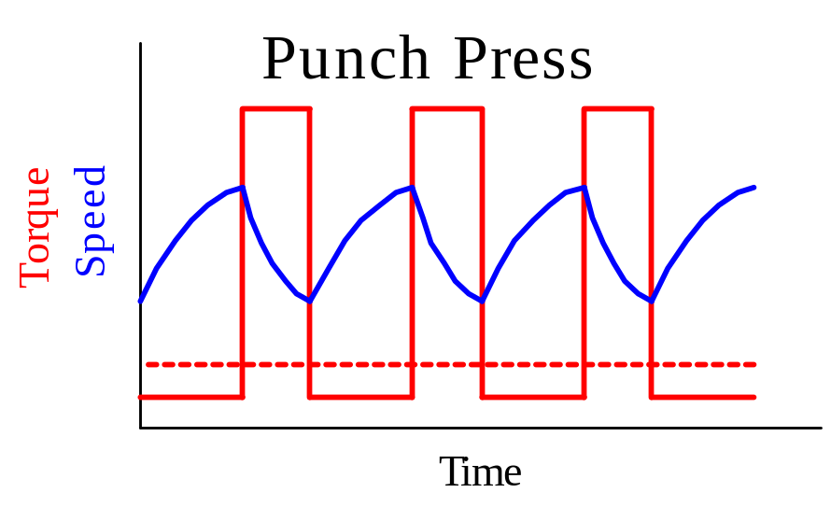
NEMA Class D Typical Application

Induction Motor Parameter Variation:

- Frequency Effects
  - Rotor Slip Frequency Effects
    - R increases with frequency (good)
    - L decreases with frequency (partly good)
  - Stator Skin Effects (bad)
- Flux Level (Saturation)

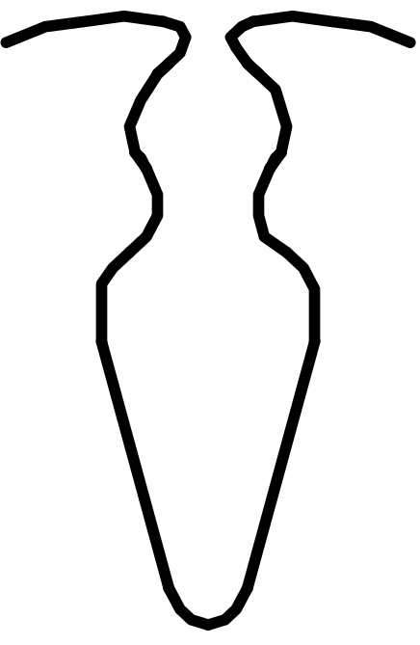
Double Cage Induction Motor Rotor Slot

Induction Motor Performance Summary:

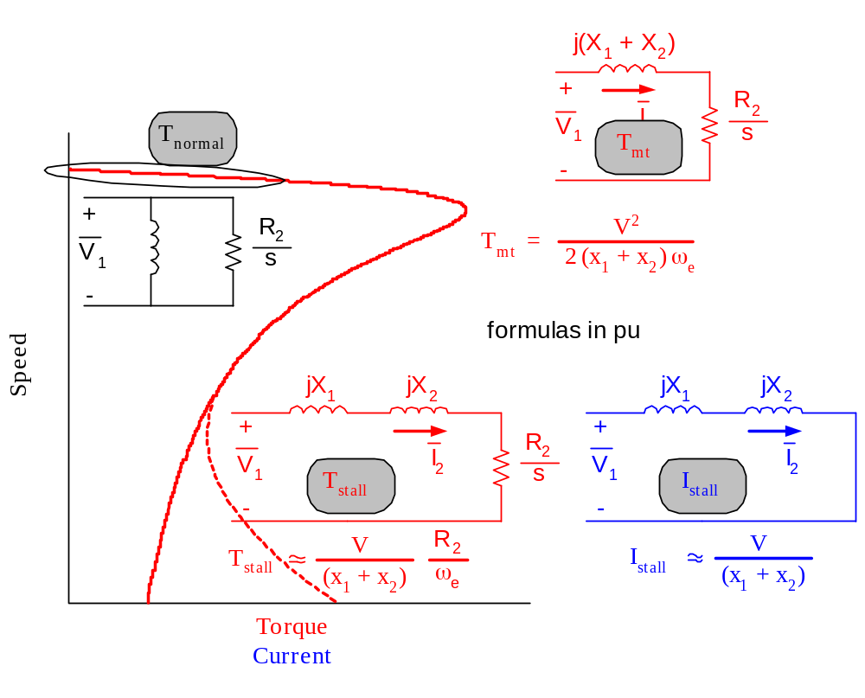
Induction Motor Performance Summary

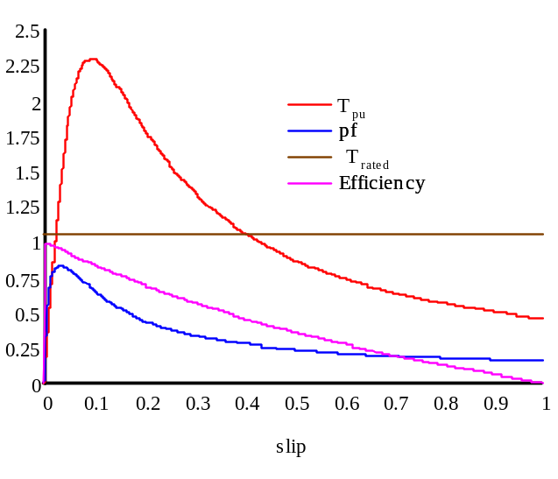
Induction Motor Performance vs. Slip

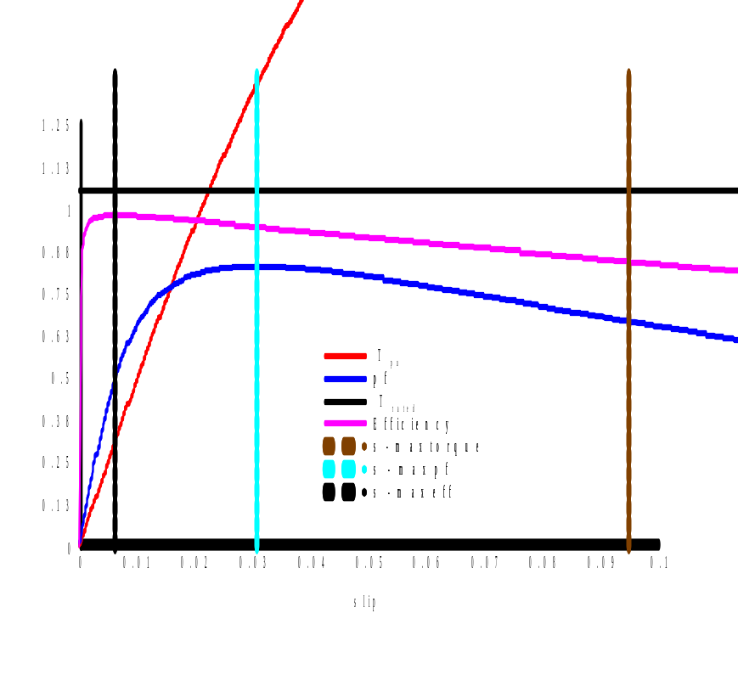
Zoomed-in Induction Motor Performance vs. Slip

